Міністерство освіти і науки, молоді та спорту України
Національний технічний університет України
«Київський політехнічний інститут»
Факультет інформатики та обчислювальної техніки
Кафедра обчислювальної техніки

Лабораторна робота №8
З дисципліни «Oб’єктно-орієнтоване програмування»
Тема: «Робота з потоками в мові програмування Java»

Виконав:
студент групи ІВ-71
Мазан Я. В.
Номер залікової книжки:
7109
Перевірив:
Подрубайло О. О.

Київ 2018
1. Варіант завдання.
Номер залікової книжки — 7109

2. Код програми
Файл Main.java:
import java.io.*;

public class Main {

public static void main(String[] args) throws IOException, ClassNotFoundException, MyException {
String destination = System.getProperty("user.dir")+ "/data/";
new File(destination).mkdirs();
Serializing worksWithFile = new Serializing();
TestSerializing tests = new TestSerializing();
Vegetable a = new Vegetable("Помідор", 12);
Vegetable b = new Vegetable("Огірок", 8);
Vegetable c = new Vegetable("Цибуля", 5);
Vegetable d = new Vegetable("Морква", 13);
VegetablesCollection salad = new VegetablesCollection();
salad.add(a);
salad.add(b);
salad.add(c);
salad.add(d);
worksWithFile.writeCollectionAsObjectsList(salad, destination + "Objects List");
worksWithFile.writeCollectionAsOneObject(salad, destination + "One Object");
worksWithFile.writeCollectionAsText(salad, destination + "Text");
tests.testReadCollectionAsText();
tests.testReadCollectionAsOneObject();
tests.testReadCollectionAsObjectsList();
VegetablesCollection saladRead = worksWithFile.readCollectionAsObjectsList(destination + "Objects List");
System.out.println("Зчитаний із текстового файлу салат");
for (Object i : saladRead) {
System.out.println(i);
}
System.out.println("\nНезчитаний салат");
for (Object i : salad) {
System.out.println(i);
}
}
}
Файл Serializing.java:
mport java.io.*;

/**
* Class which describes methods for working with input and output streams
* writes to files and reads data from them
*/
public class Serializing {

/**
* Method that writes a collection into a file as single object
* @param collection
* @param nameOfFile
* @throws IOException
*/
public void writeCollectionAsOneObject(VegetablesCollection collection, String nameOfFile) throws IOException{
File file = new File(nameOfFile);
FileOutputStream fileOutputStream = new FileOutputStream(file);
ObjectOutputStream output = new ObjectOutputStream(fileOutputStream);

output.writeObject(collection);

output.close();
}

/**
* Method that writes a collection into a file as list of objects from whose the collection consists of
* @param collection
* @param nameOfFile
* @throws IOException
*/
public void writeCollectionAsObjectsList(VegetablesCollection collection, String nameOfFile) throws IOException{
File file = new File(nameOfFile);
FileOutputStream fileOutputStream = new FileOutputStream( file);
ObjectOutputStream output = new ObjectOutputStream(fileOutputStream);
for (Object i: collection){
output.writeObject(i);
}
output.close();
}

/**
* Method that writes a collection into a text file with information about its objects
* @param collection
* @param nameOfFile
* @throws IOException
*/
public void writeCollectionAsText(VegetablesCollection collection, String nameOfFile) throws IOException {
File file = new File(nameOfFile);
FileWriter fileOutputStream = new FileWriter(file);
BufferedWriter output = new BufferedWriter(fileOutputStream);
for (Object i: collection){
output.write(i.toString() + "\n");
}
output.close();
}

/**
* Method that reads collection from a file that includes a raw data with not modified collection
* @param nameOfFile
* @return VegetablesCollection collection
* @throws IOException
* @throws ClassNotFoundException
*/
public VegetablesCollection readCollectionAsOneObject(String nameOfFile) throws IOException, ClassNotFoundException{
File file = new File(nameOfFile);
FileInputStream fileInput = new FileInputStream(file);
ObjectInputStream objectInput = new ObjectInputStream(fileInput);
VegetablesCollection collection = (VegetablesCollection)objectInput.readObject();
objectInput.close();
return collection;
}

/**
* Method that reads collection from a file that includes a raw data with list of objects from whose the collection consists of
* @param nameOfFile
* @return VegetablesCollection collection
* @throws IOException
* @throws ClassNotFoundException
*/
public VegetablesCollection readCollectionAsObjectsList(String nameOfFile) throws IOException, ClassNotFoundException{
File file = new File(nameOfFile);
FileInputStream fileInput = new FileInputStream(file);
ObjectInputStream objectInput = new ObjectInputStream(fileInput);
VegetablesCollection collection = new VegetablesCollection();
try{
Vegetable veg = (Vegetable) objectInput.readObject();
while (true) {
collection.add(veg);
veg = (Vegetable) objectInput.readObject();
}
} catch (EOFException e) {
objectInput.close();
}
return collection;
}

/**
* Method that reads collection from a file that includes a text with information from which the collection can be revived
* @param nameOfFile
* @return VegetablesCollection collection
* @throws IOException
* @throws ClassNotFoundException
*/
public VegetablesCollection readCollectionAsText(String nameOfFile) throws IOException, MyException, ClassNotFoundException{
File file = new File(nameOfFile);
FileReader fileInput = new FileReader(file);
BufferedReader objectInput = new BufferedReader(fileInput);
VegetablesCollection collection = new VegetablesCollection();
String inputLine = objectInput.readLine();
while (inputLine != null) {
String[] values = inputLine.split(" ");
String vegName = values[1];
int nutrition = Integer.parseInt(values[3]);
Vegetable veg = new Vegetable(vegName, nutrition);
collection.add(veg);
inputLine =objectInput.readLine();
}
objectInput.close();
return collection;
}
}
Файл TestSerializing.java:
/**
* Testing my Serializator that works with files
*/
import org.junit.Test;
import java.io.*;
import static org.junit.Assert.*;

public class TestSerializing {

/**
* Initialising variables for testing
*/
private static final String destination = System.getProperty("user.dir")+ "/data/";

private VegetablesCollection testCollection;
private Serializing workWithFile;

/**
* Testing of method writeCollectionAsOneObject()
*/
@Test
public void testWriteCollectionAsOneObject() throws IOException,MyException{
new File(destination).mkdirs();
workWithFile = new Serializing();
Vegetable a = new Vegetable("Помідор", 12);
Vegetable b = new Vegetable("Огірок", 8);
testCollection = new VegetablesCollection();
testCollection.add(a);
testCollection.add(b);
workWithFile.writeCollectionAsOneObject(testCollection, destination + "raw collection");
boolean check = new File(destination, "raw collection").exists();
assertTrue(check);
}

/**
* Testing of method writeCollectionAsObjectsList()
*/
@Test
public void testWriteCollectionAsObjectsList() throws IOException,MyException{
workWithFile = new Serializing();
Vegetable a = new Vegetable("Помідор", 12);
Vegetable b = new Vegetable("Огірок", 8);
testCollection = new VegetablesCollection();
testCollection.add(a);
testCollection.add(b);
workWithFile.writeCollectionAsObjectsList(testCollection, destination + "objects list");
boolean check = new File(destination, "objects list").exists();
assertTrue(check);
}

/**
* Testing of method writeCollectionAsText()
*/
@Test
public void testWriteCollectionAsText() throws IOException,MyException{
workWithFile = new Serializing();
Vegetable a = new Vegetable("Помідор", 12);
Vegetable b = new Vegetable("Огірок", 8);
testCollection = new VegetablesCollection();
testCollection.add(a);
testCollection.add(b);
workWithFile.writeCollectionAsText(testCollection, destination+"text");
boolean check = new File(destination, "text").exists();
assertTrue(check);
}

/**
* Testing of method readCollectionAsOneObject(
*/
@Test
public void testReadCollectionAsOneObject() throws IOException, ClassNotFoundException, MyException {
workWithFile = new Serializing();
Vegetable a = new Vegetable("Помідор", 12);
Vegetable b = new Vegetable("Огірок", 8);
testCollection = new VegetablesCollection();
testCollection.add(a);
testCollection.add(b);
workWithFile.writeCollectionAsOneObject(testCollection, destination+"raw collection");
testCollection = workWithFile.readCollectionAsOneObject(destination + "raw collection");
assertEquals(testCollection.size(),2);
}

/**
* Testing of method readCollectionAsObjectsList
*/
@Test
public void testReadCollectionAsObjectsList() throws IOException, ClassNotFoundException, MyException{
workWithFile = new Serializing();
Vegetable a = new Vegetable("Помідор", 12);
Vegetable b = new Vegetable("Огірок", 8);
testCollection = new VegetablesCollection();
testCollection.add(a);
testCollection.add(b);
workWithFile.writeCollectionAsObjectsList(testCollection, destination+"objects list");
testCollection = workWithFile.readCollectionAsObjectsList(destination + "objects list");
assertEquals(testCollection.size(),2);
}

/**
* Testing of method readCollectionAsText()
*/
@Test
public void testReadCollectionAsText() throws IOException, ClassNotFoundException, MyException{
workWithFile = new Serializing();
Vegetable a = new Vegetable("Помідор", 12);
Vegetable b = new Vegetable("Огірок", 8);
testCollection = new VegetablesCollection();
testCollection.add(a);
testCollection.add(b);
workWithFile.writeCollectionAsText(testCollection, destination+"text");
testCollection = workWithFile.readCollectionAsText(destination + "text");
assertEquals(testCollection.size(),2);
}
}

3. UML-діаграма класів
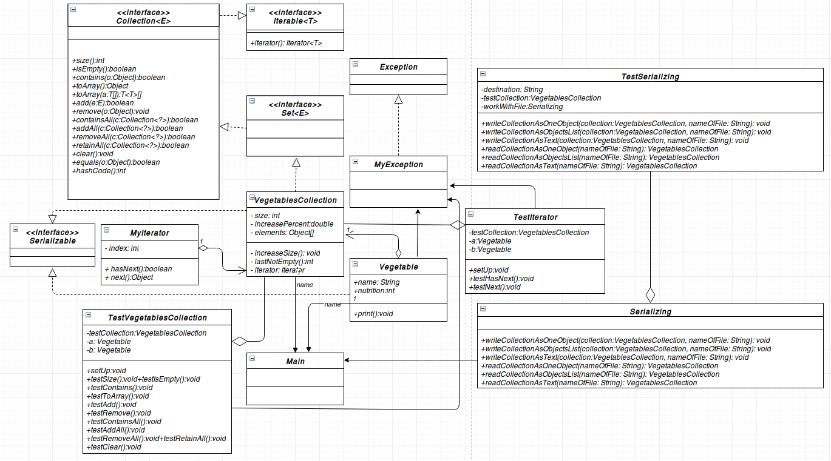
4. Висновок
При виконанні цієї лабораторної роботи я вирішив зберігати робочі файли в окрему директорію, тому мені довелось зробити її створення автоматичним залежно від операційної ситеми.

